Session # 1
“Administrative”

Learning Objectives
- Complete Administrative Packet
- Counseling vs Coaching Discussion
- Tell me about yourself

SESSION #1

 | Reflection | The purpose of the first session is complete the required administrative forms and gain an understanding as to how Mental Health Coaching works in assisting the individual to meet their goals.
□ | Administrative | These forms required for completion are typically be completed in the office. If needed the form can be taken home and turned back in upon the next session. A copy of all forms will be provided to the client and originals will be in a secured file.
□ | Counseling vs Coaching | Tells the difference3s between a mental health coach and a counselor.
□ | Clarity In Motion Workbook | The Clarity In Motion workbook will be provided in this session. This review will allow for a use of practical exercise to demonstration the instructions were understood, and the client can continue with minimal guidance in how to use the workbook.
□ | Tell me about yourself | We open our sequence of sessions with an understanding of the Individual’s past life story. This is completed to have an understanding of what may be influencing the behavior of the present and may also impact the behavior in the future.

Administrative

Health Information Portable Privacy Act (HIPPA)

- As a general rule, the NBHWC holds the position that health and wellness coaches should manage client/patient personal health information and records according to the policies and procedures as established by the Health Insurance Portability and Accountability Act (HIPAA).

So long as the patient does not object, HIPAA allows the provider to share or discuss a patient's mental health information with the patient's family members.

Health information such as diagnoses, treatment information, medical test results, and prescription information are considered protected health information under HIPAA, as are national identification numbers and demographic information such as birth dates, gender, ethnicity, and contact and emergency contact.

The HIPAA Privacy Rule is not intended to prohibit providers from talking to each other and to their patients.

Information can be shared without consent if it is justified in the public interest or required by law.

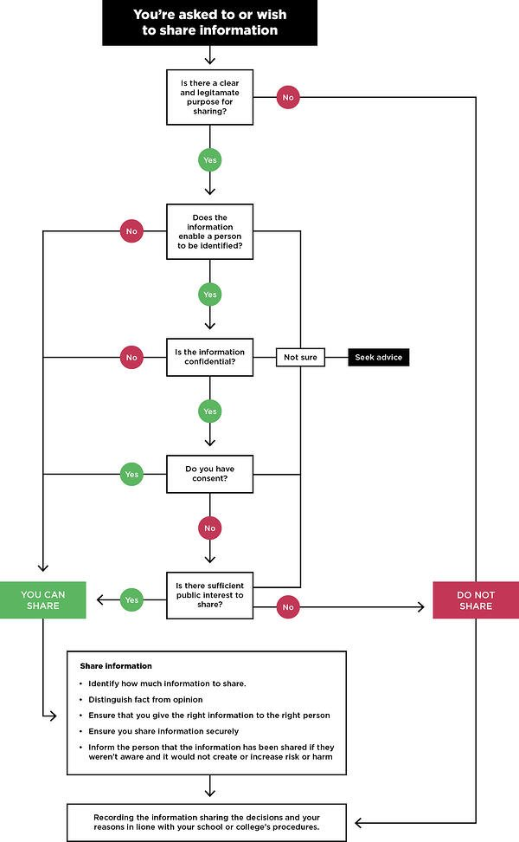

Confidentiality Statement

This agreement is made between ____________________ (“Coach”) and ____________________ (“Client”) on this ____ day of ____, 20__. Both parties agree to the following:

Coaching is a collaborative process with an ongoing relationship between the Client and Coach. The coaching experience supports the Client in establishing new behaviors.

The coaching relationship is strengths-based, forward-looking, and collaborative.

The coaching agenda is developed and implemented in partnership between the Client and Coach.

The role of the Coach is to help the Client progress toward achieving a goal.

The Client and Coach agree to engage fully in the coaching experience.

The Client recognizes that coaching is not therapy, counseling, or consulting.

Confidentiality

The Coach agrees to keep all conversations and information with the Client private and confidential, as allowable by law.

No personal information will be shared with anyone without the Client’s express permission. Exceptions may be made if there is an imminent threat of serious injury to oneself or someone else.

Coaching Commitment

By entering into this relationship, the Client and Coach acknowledge that the Client desires to make a behavioral change or some type of improvement in his or her life. Behavioral change often takes time to implement and sustain. The pace of change is uncertain and varies amongst individuals. As such, the Client and Coach agree to a minimum of a 3-month relationship.

Coaching Session Procedures

Coaching sessions may occur in person, by phone, through video conference, or over email, depending on the venue that works best for the Client and what coaching package is selected.

The Coach and Client agree to adhere to established appointment times.

The Coach and Client agree to begin and finish all appointments on time. If the Client is more than 15 minutes late to an appointment, the Coach will assume that the appointment is canceled, and the Client will be responsible for the full coaching fee.

If the Coach is more than 15 minutes late to an appointment, the Client may assume that the session is canceled, and the Client shall not be responsible for any payment for that session.

The Client agrees to cancel or reschedule an appointment at least 24 hours in advance, without a change fee. Any changes or cancellations within 24 hours are subject to a 50% cancellation fee.

Coaching Fees

Specific coaching fees and packages are outlined in Schedule

For each of these packages,

The Coach requests a 3-month commitment from the Client.

If the Client desires to terminate the relationship prior to 3 months, at least 30 days advance notice is required for a full refund of remaining sessions.

Fees are payable at the first of the month, and prior to the coaching services being provided each month.

Payments may be made by cash, check, credit card, or electronic funds transfer (EFT).

_________________________________________________________ _________________________________________________________

Signatures to this Agreement:

Coach Date

__________________________________________________________________

Client Date

Emergencies

In case of an emergency, do not call your mental health coach,

Call 911

or go to your nearest emergency room.

Tell me About Yourself

In this session we want to have an understanding of your past life with a clearer framework of any trauma or negative event that may have occurred earlier in your life.

Childhood years (up to age 13)

Key Events: (In general events that happened, who was involved, how did you deal with it)

1.

2.

3.

Trauma in this timeline: (date and label trauma on the timeline)

|________|_________|________|_______|_______|_______|______|______

Teen years ( from 13-20)

Key Events: (In general the events that happened, who was involved, how did you deal with it)

1.

2.

3.

Trauma in this timeline: (date and label trauma on the timeline)

|________|_________|________|_______|_______|_______|______|______

Early Adult years ( from 20 – 35)

Key Events: (In general the events that happened, who was involved, how did you deal with it)

1.

2.

3.

Trauma in this timeline: (date and label trauma on the timeline)

|________|_________|________|_______|_______|_______|______|______

Middle Adult years

Key Events: (what happened, who was involved, how did you deal with it)

1.

2.

3.

Trauma in this timeline: (date and label trauma on the timeline)

|________|_________|________|_______|_______|_______|______|______

Senior years

Key Events: (what happened, who was involved, how did you deal with it)

1.

2.

3.

Trauma in this timeline: (date and label trauma on the timeline)

|________|_________|________|_______|_______|_______|______|______

Tell me about your journey with God

(optional)

Childhood years

Key Events: (what happened, who was involved, how did you deal with it)

1.

2.

3.

Teen years

Key Events: (what happened, who was involved, how did you deal with it)

1.

2.

3.

Early Adult years

Key Events: (what happened, who was involved, how did you deal with it)

1.

2.

3.

Middle Adult years

Key Events: (what happened, who was involved, how did you deal with it)

1.

2.

3.

Senior years

Key Events: (what happened, who was involved, how did you deal with it)

1.

2.

3.

