Session # 2 Objectives and Goals

Learning Objectives:

1. Assessing the Current Situation

2. Establishing Goals and Objectives

3. Identifying Key Relationships and Quality of Life

# SESSION #2: Objectives and Goals

|  |  |  |
| --- | --- | --- |
|  | Reflection | To more clearly understand that changes come from setting goals to start where we are and move into what we want to go towards. |
| □ | Values, what are yours | Discovery is a part of assessment of a current situation involves a review of major challenges, what are the current objectives. |
|  | Establishing Goals & Objectives | Identifying how goals are established and objectives are designed to build towards meeting goals. |
| □ | Identify Key Relationships & Quality of Life | Understanding how relationships between people and organizations influences obtaining goals and quality of life. |
| □ | Goals Worksheet Session #4 | Setting up realistic Goals to work through prior to the next meeting. Practice what was learned in Seminar #4. |

**Assessing the current situation**

**What are your current major challenges?**

.1

2.

3.

4.

5.

**How have you approached these challenges and what was the outcome for each?**

1. ______________________________________________________________________________________________________________________________________________________________________________________________________________________________________________________

2. ______________________________________________________________________________________________________________________________________________________________________________________________________________________________________________________

3. ______________________________________________________________________________________________________________________________________________________________________________________________________________________________________________________

4. ______________________________________________________________________________________________________________________________________________________________________________________________________________________________________________________

5. ______________________________________________________________________________________________________________________________________________________________________________________________________________________________________________________

**Who was involved in the challenge? response?**

1.

2.

3.

4.

5.

**What are your primary objectives?**

**To improve your performance in a key area of life?**

**To understand something more clearly?**

**To gain something new?**

**To fix something broken?**

**Establishing Goals and Objectives**

**GOAL:**

To establish what this will look like once completed?

This goal will look like …….

To Identify resources required?

To complete this goal we will need……

To Identify Timeline for this to occur, start to finish?

Upon starting this goal, it will take this time period before it will be finished ……..

**OBJECTIVE: (Objectives when completed build to finish the Goal)**

To establish what this will look like once completed?

This objective will look like …….

To Identify resources required?

To complete this objective, we will need……

To Identify Timeline for this to occur, start to finish?

Upon starting this objective, it will take this time period before it will be finished

**Identify Key Relationships & Quality of Life**

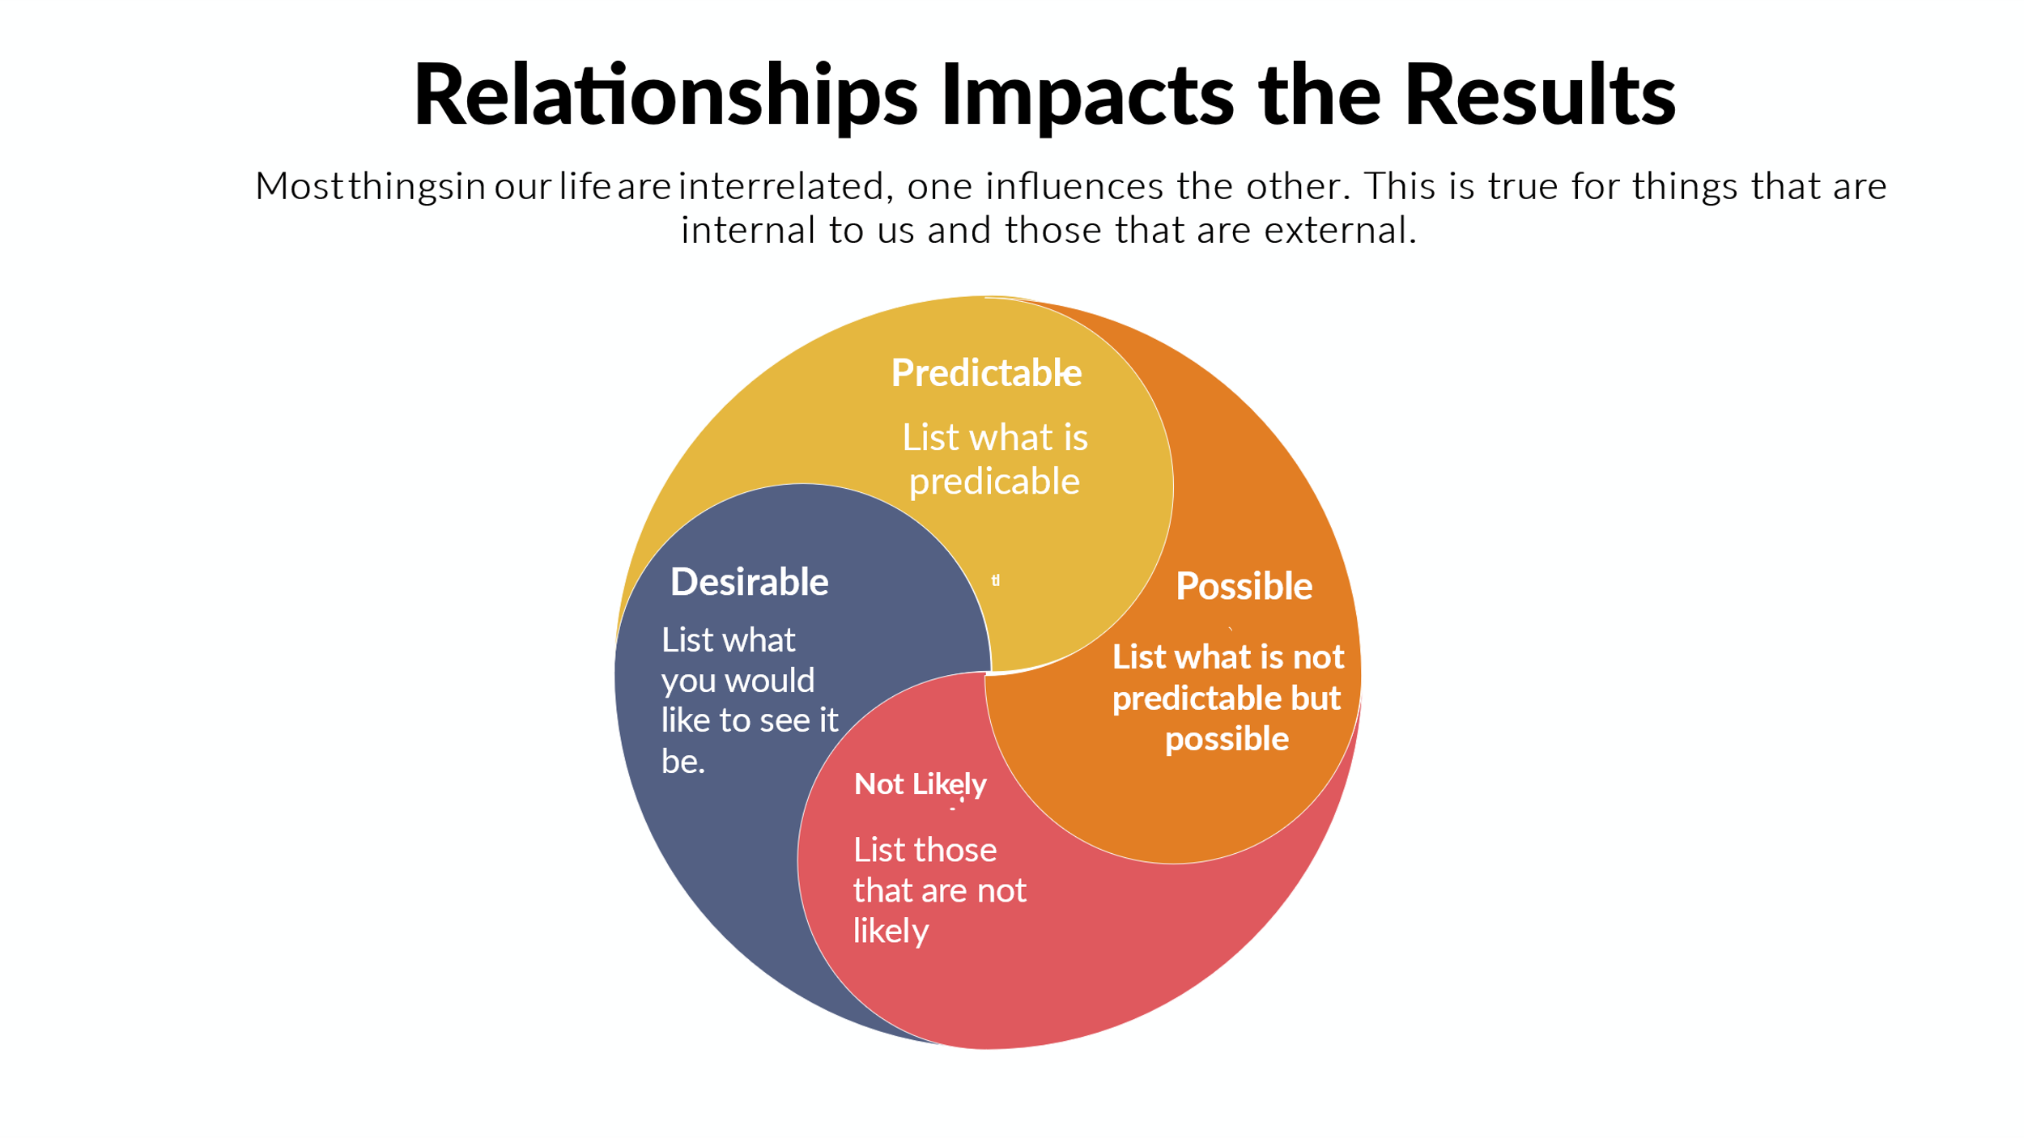

**Desired Quality of Life**

How will this relationship impact the quality of life, in what way?

Predictable:

Possible:

Not Likely:

Desirable:

**Monitoring Goals Progress**

How will you monitor your goals?

________________________________________________________________________________________________________________________________________________________________________________________________________________________________________________________________________________________________________________________________________________________________________________________________________________________________________________________________________________________________________________________________________________________________________________________________________________________________________________________________________________

What criteria will you use to gauge progress?

________________________________________________________________________________________________________________________________________________________________________________________________________________________________________________________________________________________________________________________________________________________________________________________________________________________________________________________________________________________________________________________________________________________________________________________________________________________________________________________________________________

**Time Management**

1. Urgent and Important
2. Not Urgent and Important
3. Not Important And Urgent
4. Not Important and Not Urgent

**Resource Management**

Time is a resource:

Finances is a resource

Human Capital is a resource

Communication is a resource

**Assignment Goals for Session # 6**

* + - 1. Write a Quarterly goals
      2. Write out Monthly Goal
      3. Write out first Month Weekly Goal
      4. Write our First Week Daily Goal