Family Member Self-Assessment

Which Seminar to Take?

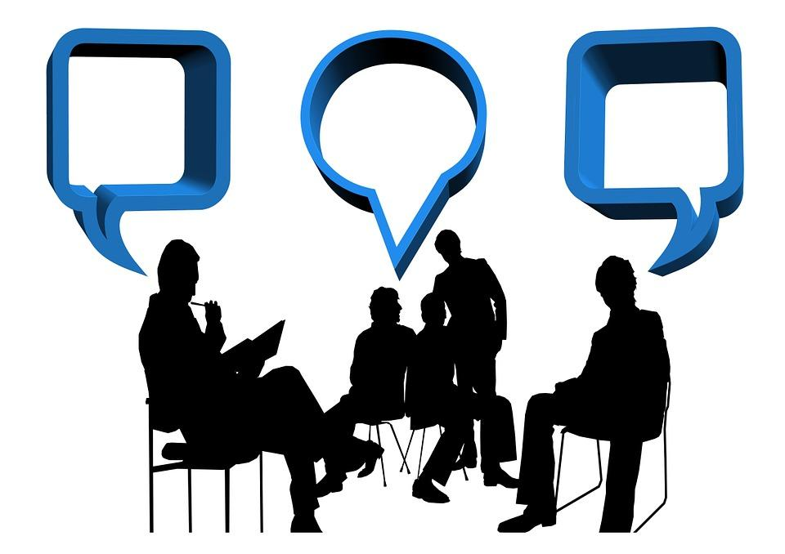

SEMINAR SELECTION QUESTIONAIR & ASSIGNMENT
For families living with substance use disorders

Instructions:
There are 32 seminars. Each seminar is a separate issue (problem) the family is likely to face in their journey with substance use disorders. The 32 seminars are broken into four categories of focus: 1. The Family Dynamic, 2. The Disease, 3. The Family Core Competency (12 seminars), 4. The Families Capacity to Take Action.
Using this Self-Assessment Tool, you will determine which of the 32 key issues to take first.

Your Self-Assessment

TABLE OF CONTENTS

PART ONE: Family Member Self-Assessment Survey ………. ………..……… 3
PART TWO: Family Members Self-Assessment Seminar Learning Objectives ... 4
PART THREE: Family Member Self-Assessment Seminar Selection Card …….… 10
PART FOUR: Family Member Seminar Selection Report Card …………………. 13
PART FIVE: Ordering Books…………………………………….……………… 14

PART ONE

Family Member Self-Assessment Survey

Category I (Family Dynamic) Seminars #1-5.
What is the ability of your family members to deal with the issues (problems) related to living with substance use disorders? Rate using a scale of 1 to 10 where 1 is the lowest ability and 10 is the highest ability.
_____ Rating. (Family Dynamic Score)
Category II (The Disease) Seminars #6-9.
How well does your family understand this disease? Rate using a scale of 1 to 10 where 1 is the lowest ability and 10 is the highest ability.
_____ Rating. (The Disease Score)
Category III (The Family Core Competency ) Seminars #10-21.
How well does the family understand each core issue (problem), the impact of the disease and how to best respond? Rate using a scale of 1 to 10 where 1 is the lowest ability and 10 is the highest ability.
_____ Rating. (The Core Competency Score)
Category IV (Family Dynamic) Seminars #22-32.
How well does your family know which services in the community to look for, where to find them and how to engage them for assistance. Rate using a scale of 1 to 10 where 1 is the lowest ability and 10 is the highest ability.
_____ Rating. (Family Capacity to Take Action)

Rank in order of the lowest to the highest score for each category. From this ranking of scores choose seminars in the category with the lowest score, The Family Dynamic, The Disease, The Core Competency Issues, Family Capacity to Take Action.
1.
2.
3.
4.

In a paragraph describe the following:

In what way is this substance use disorder impacting the family?
What unresolved issues are currently having the greatest impact?
PART TWO
The Seminar Learning Objectives

The Family Dynamic Category (ISSUES # 1-5)

ISSUE # 1. Family is a system.
Seminar Goal: The family sees each family members as a partner in the family system, contributing to the family dynamic.
Three Learning Objective: 1. Learn each family members Functionality, 2. Learn their Potentiality, 3. Learn the Obstacles that prevents the family members from contributing to the family dynamic.

ISSUE # 2. Different roles of the family members.
Seminar Goal: The family sees each family members in the role they play, understands their interaction characteristic and the sequence of thought process.
Three Learning Objective: 1. Learn the Characteristic Patterns of how family’s member interacts, 2. Learn the 7 different roles family member play, 3. Understanding the sequence of thought, how we use what we know.

ISSUE # 3. Childhood trauma and SUD.
Seminar Goal: Understand what to look for and how to seek professional assistance in Childhood Trauma.
Three Learning Objectives: 1. Learn what is childhood trauma, 2. Learn the signs of childhood trauma, 3. Understanding the tools used to diagnose childhood trauma.

ISSUE # 4. Different types of family therapy.
Seminar Goal: As a consumer, learn the different types of family therapy practices. What to ask for when seeking family therapy.
Three Learning Objectives: 1. Learn the different types of family therapy, 2. Learn which are the four (4) predominate type models, 3. Learn why SUD is referred to as a family disease.

ISSUE # 5. Four primary support structures of the family.
Seminar Goal: Understand the different areas of the community that support the family.
Three Learning Objectives: 1. Learn which are the four (4) primary family support structures, 2. Learn how to get organized to get the most from these organizations, 3. Understanding how to use a plan of action in approaching these groups.

The Disease Category, (Issues # 6-9)
ISSUE # 6. Getting a diagnosis.
Seminar Goal: Learn the difference between diagnosis, why all three are needed.
Three Learning Objectives: 1. Learn the medical diagnosis path, 2. Learn the mental health diagnosis path, 3. Learn the Addiction diagnosis path. 4. Get an assessment (screening), Diagnosis, Staging, 5. Get organized.

ISSUE # 7. SUD is a brain disease.
Seminar Goal: Learn why we know this is a brain disease.
Three Learning Objectives: 1. Learn why addiction is a brain disease, 2. How it is different from other disease, 3. Learn Why it is chronic.

ISSUE # 8. The disease progresses in stages.
Seminar Goal: Learn in what ways the disease progresses.
Three Learning Objectives: 1. Learn the 7 stages of progression, 2. Lean the importance of “Individualized Treatment, 3. Learn the three (3) levels “stages” of disease, (mild, moderate, sever).

ISSUE # 9. Relapse is a part of the disease journey.
Seminar Goal: :Learn why relapse is occurring.
Three Learning Objectives: 1. Learn the types of mental health therapy in recovery, 2. How the value of Medical Assisted Treatment (M.A.T.) in recovery, 3. Learn to support their Collaborative Comprehensive Care Plan (CC Care Plan) to deal with an enabler who is in denial of their enabling behavior.

The Family Core Competency Category, (Issues # 10-21)

ISSUE # 10. Enabling vs. Disabling
Seminar Goal: Learn to identify enabling and then disable it as a pattern.
Three Learning Objectives: 1. Learn the 10 Types of Enabling, 2. How to deal with an enabler who is in denial of their enabling behavior, 3. Understanding how to change enabling behavior.

ISSUE # 11. Addiction Behavior, Boundaries.
Seminar Goal: Setting Boundaries related to addiction behaviors.
Three Learning Objectives: 1. To learn the behavior traits of substance misuse, 2. To understand how the behavior progresses and changes over time. 3. To learn how to responds to these behaviors by setting boundaries.

ISSUE # 12. Family Intervention, five stages of change & motivational interviewing.
Seminar Goal: Learn why the theory of change is the foundation of an intervention.
Three Learning Objectives: 1. Identify the five stages of change and motivational interviewing to address them, 2. Learn the ten processes of change. 3. Gain an understanding dual diagnosis, mental health condition,

ISSUE # 13. The Police Intervention
Seminar Goal: How to prepare for the police, what is taking place.
Three Learning Objectives: 1. Identify the six phases of Police intervention, 2. Learn the do’s and do not’s of a missing person’s report, 3. How to compete a missing person’s report.

ISSUE # 14. The Emergency Medical Services Intervention
Seminar Goal: What are the needed steps by the family members at the emergency room.
Three Learning Objectives: 1. Understand the paramedic first response phrases, 2. Learn what happens in a hospital emergency room visit. 3. Understanding the value of SBIRT, family role in continuity of care.

ISSUE # 15. The Legal System Intervention
Seminar Goal: How the legal system works related to substance use disorders cases.
Three Learning Objects: 1. Have a working knowledge of the incarceration diversion or Sequential Intercept Model (SIM), 2. Finding an attorney, 3. What is Drug Court.

ISSUE # 16. The Treatment Center Intervention
Seminar Goal: How to approach, what to expect in a treatment center experience.
Three Learning Objectives: 1. Determine the right level of treatment, 2. What is Intensive Outpatient Treatment, IOP. 3. Family role in communicating with treatment center staff.

ISSUE # 17. Support Agency Mapping
Seminar Goal: Understand what services are available in your community.
Three Learning Objectives: 1. Define family community mapping (who can assist the family), 2. Steps to create a family community map 3. Advantages gained by having a family community map.

ISSUE # 18. The Relapse.
Seminar Goal: Know the difference between each stage of relapse.
Three Learning Objectives: 1. What is relapse, 2. List three stages of relapse, 3. How can the family identify these stages.

ISSUE # 19. Successful Lifelong Recovery.
Seminar Goal: What are the elements of a lifelong recovery plan.
Three Learning Objectives: 1. Four main ideas in relapse prevention. 2. Learn the Stages of Recovery 3. How to create a strong support system.

ISSUE # 20. Bereavement.
Seminar Goal: Understand the segments of bereavement.
Three Learning Objectives: 1. Learn the 3 types of grief, 2. Understand the grief cycle, 3. Create an inventory for complicated grief.

ISSUE # 21. Faith, Spiritual Practices.
Seminar Goal: How to assist a faith practice organization start an Invest in the Family Ministry.
Three Learning Objectives: 1. Review the need for faith organization participation, 2. Create an Invest in the Family Ministry, 3. Offer the “Invest in the Family Ministry” program at your place of worship.

The Families Capacity to Take Action, (Issues 22-33)

ISSUE # 22. Elements of a family plan of action.
Seminar Goal: What is needed to create an effective family plan of action.
Three Learning Objectives: 1. Learn elements of a family plan of action, 2. Learn the steps in developing a family plan of action. 3. Be aware of the obstacles in developing a plan of action.

ISSUE # 23. Roles family members play in a plan of action.
Seminar Goal: Each family needs to understand their role in the family plan of action.
Three Learning Objectives: 1. Learn to identify and manage triangulation relationships, 2. How to deal with the six common characteristics of family unit living with substance use disorders, 3. Identify existing communication patterns within the family members.

ISSUE # 24. Getting networked in advance.
Seminar Goal:
Three Learning Objectives: 1. How to use the Family Solution Finder Local Resource Connections Workbook Learning Module IV, 2. How to apply community mapping into your family plan of action, 3. What steps to take in making learning module IV an action step.

ISSUE # 25. Suicide prevention.
Seminar Goal: 1. Learn the common risk factors
Three Learning Objectives: 1. Learn the warning signs, 2. Learn the silent contributor.

ISSUE # 26. Financial management in SUD.
Seminar Goal: 1. Learn the possible paths and their costs,
Three Learning Objectives: 1. How to get your financial affairs in order, 2. Learn to manage this chronic disease and your expenses.

ISSUE # 27. Foster care services.
Seminar Goal:
Three Learning Objectives: 1. Learn the serviced providers case management role, 2. How bend with the requirements, 3. Options in achieving family reunification involving substance use disorders.

ISSUE # 28. NARCAN.
Seminar Goal: 1. Learn what is NARCAN
Three Learning Objectives: 1. Learn when to use it, 2. Learn what to expect as an outcome.

ISSUE # 29. Peer to Peer Support Services.
Seminar Goal: 1. Learn what is Peer to Peer Support Service,
Three Learning Objectives: 1. Learn what is Peer to Peer Support Service, 2. How to create your own Peer to Peer concept when local service is not available, 3. Understand the value of Peer to Peer exchange.

ISSUE # 30. Medical Assisted Treatment (M.A.T.)
Seminar Goal: 1. Learn what is Medical Assisted Treatment (M.A.T.) why it has value in long term recovery,
Three Learning Objectives: 1. Learn what is Medical Assisted Treatment (M.A.T.) why it has value in long term recovery, 2. Learn as a family member how to support the inclusion of M.A.T. in the plan of care, 3. Understand the regimen and titration.

ISSUE # 31. Creating a Family Solution Finder Learning Centers.
Seminar Goal: 1. Learn how to set up a local Family Solution Finder Learning Centers for your county,
Three Learning Objectives: 1. Learn how to set up a local Family Solution Finder Learning Centers for your county, 2. How to receive instructor training (train the train), 3. Understanding how operate the center and engage the local community in a community collaboration and education.

ISSUE # 32. Harm Reduction.
Seminar Goal: 1. Learn the family member role in harm reduction,
Three Learning Objectives: 1. Learn the family member role in harm reduction, 2. How to manage ones selfcare with mindfulness of self, 3. Learn tips on how to deal with difficult people.

ISSUE # 33. The Family Members Role in the Re-Entry Process.
Seminar Goal: 1. Learn the elements of the re-entry process,
Three Learning Objectives: 1. Learn the elements of the re-entry process, 2. How to manage the family members role in the re-entry process, 3. How to identify the obstacles involved in the re-entry process.

PART THREE

Family Member Seminar Selection Card

The 32 Key Issue, Family Seminar Library
Seminar Number | Type of Delivery:  Presentation, Zoom or Self -Administrated | Date Started | Date Completed
Issue # 1
Issue # 2
Issue # 3
Issue # 4
Issue # 5
Issue # 6
Issue # 7
Issue # 8
Issue # 9
Issue #10
Issue #11
Issue #12
Issue #13
Issue #14
Issue #15
Issue #16
Issue #17
Issue #18
Issue #19
Issue #20
Issue #21
Issue #22
Issue #23
Issue #24
Issue #25
Issue #26
Issue #27
Issue #28
Issue #29
Issue #30
Issue #31
Issue #32
Issue #33

This is your selected curriculum for learning.

PART FOUR

Family Member Seminar Selection Report Card

The Seminar Assignment Progress Report Card: (indicate started, in progress, completed)
Issue # 1. | Issue # 11. | Issue # 21.
Issue # 2. | Issue # 12. | Issue # 22.
Issue # 3. | Issue # 13. | Issue # 23.
Issue # 4. | Issue # 14. | Issue # 24.
Issue # 5. | Issue # 15 | Issue # 25.
Issue # 6. | Issue # 16. | Issue # 26.
Issue # 7. | Issue # 17. | Issue # 27.
Issue # 8. | Issue # 18. | Issue # 28.
Issue # 9. | Issue # 19. | Issue # 29.
Issue # 10. | Issue # 20. | Issue # 30.
 |  | Issue # 31.
 |  | Issue # 32.
 |  | Issue # 33.

Use this worksheet to record your progress.

PART FIVE

Order Books Instructions

These Four (4) Books: www.amazon.com order by title.

- The Family Solution Finder Learning Study Guidebook Learning Module I.
- The Family Solution Finder Learning Seminar Workbook Learning Module II.
- The Family Solution Finder 3-D’s Coping Skills Workbook Learning Module III.
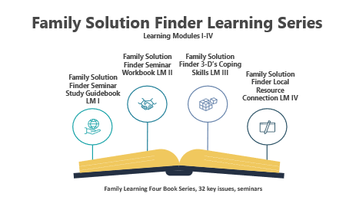
- The Family Solution Finder Local Resource Connections Workbook Learning Module IV.

Include the power point download from our website for each seminar: https://familiesimpactedbyopioids.com/32-key-issue-seminars-

